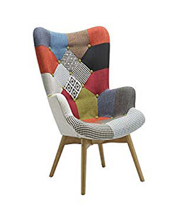

Durian berlin patched Sloane chair

$78.43

Availability: In stock

### Description

This Helsingr Chair with its fun and colorful design will brighten up any room. Upholstered in a patched polyester, this versatile lounge chair can be used as part of a living room seating arrangement or as an accent piece in a bedroom. Versatile to fit in any room setting. The footstool shown in the picture is not included in the purchase. Helsingr collection Product Care: Do not use harsh chemicals on material